CodePipeline-FE-react

Steps
Step1: Upload the Frontend code to github/gitlab repo
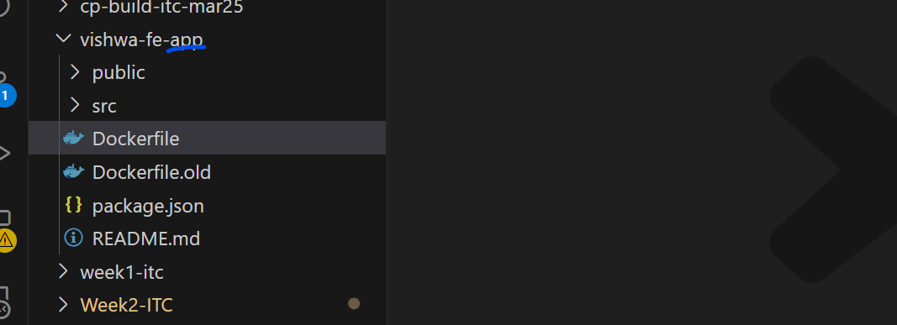
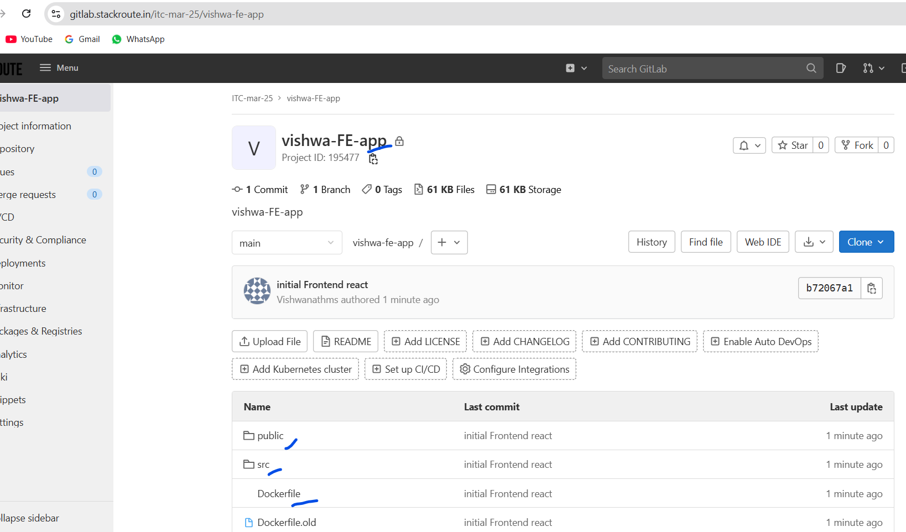

Step2: Create pipeline

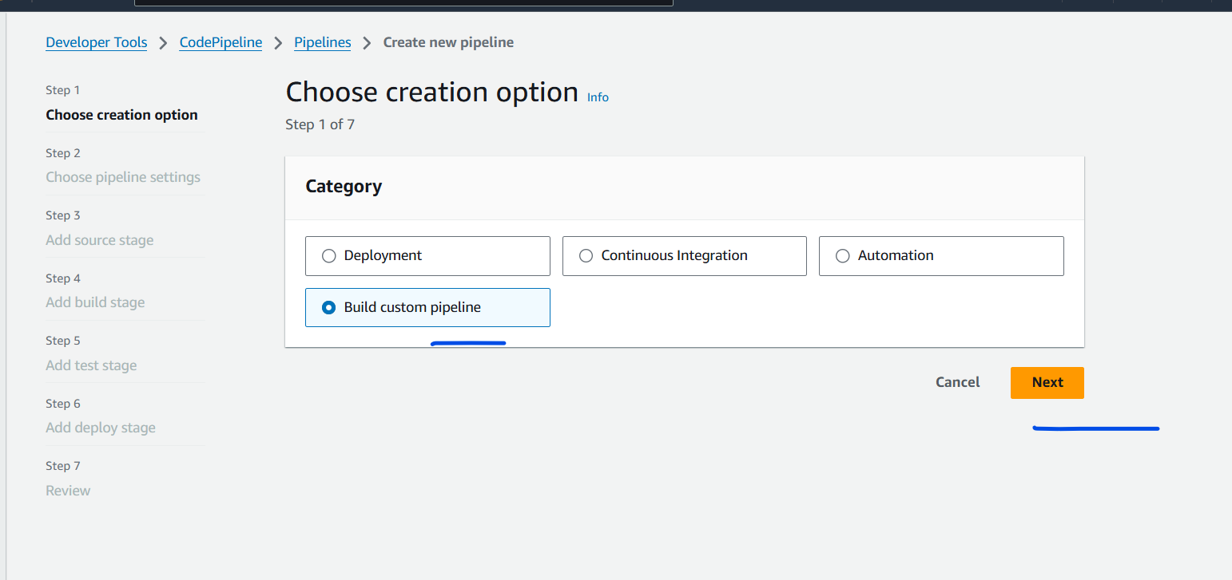
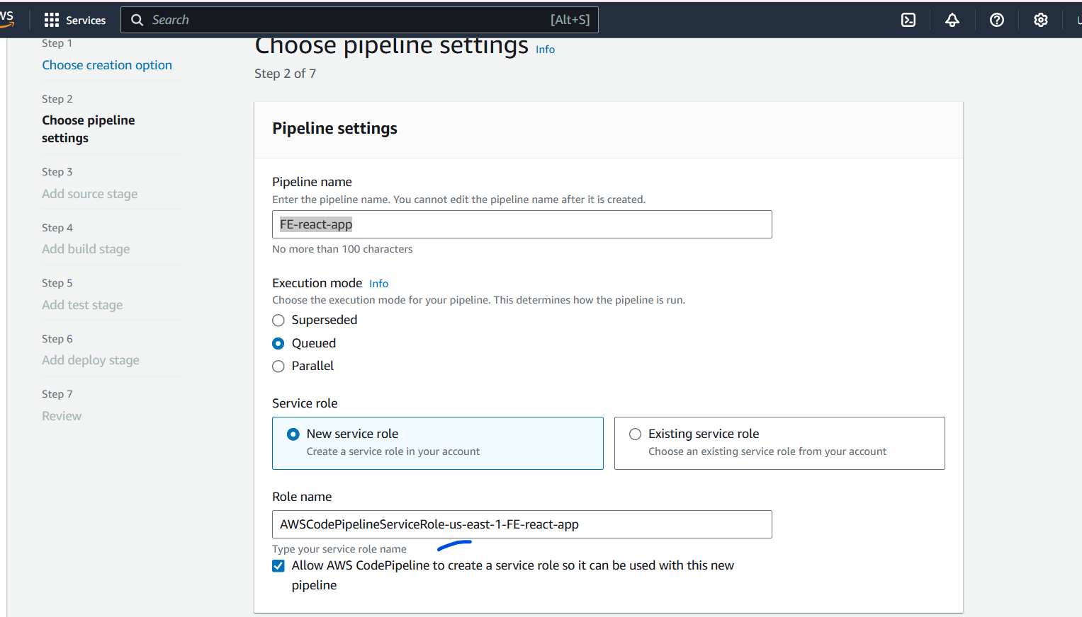
This would create an IAM role for this pipeline, which is usefull to add all the required IAM policy in that.
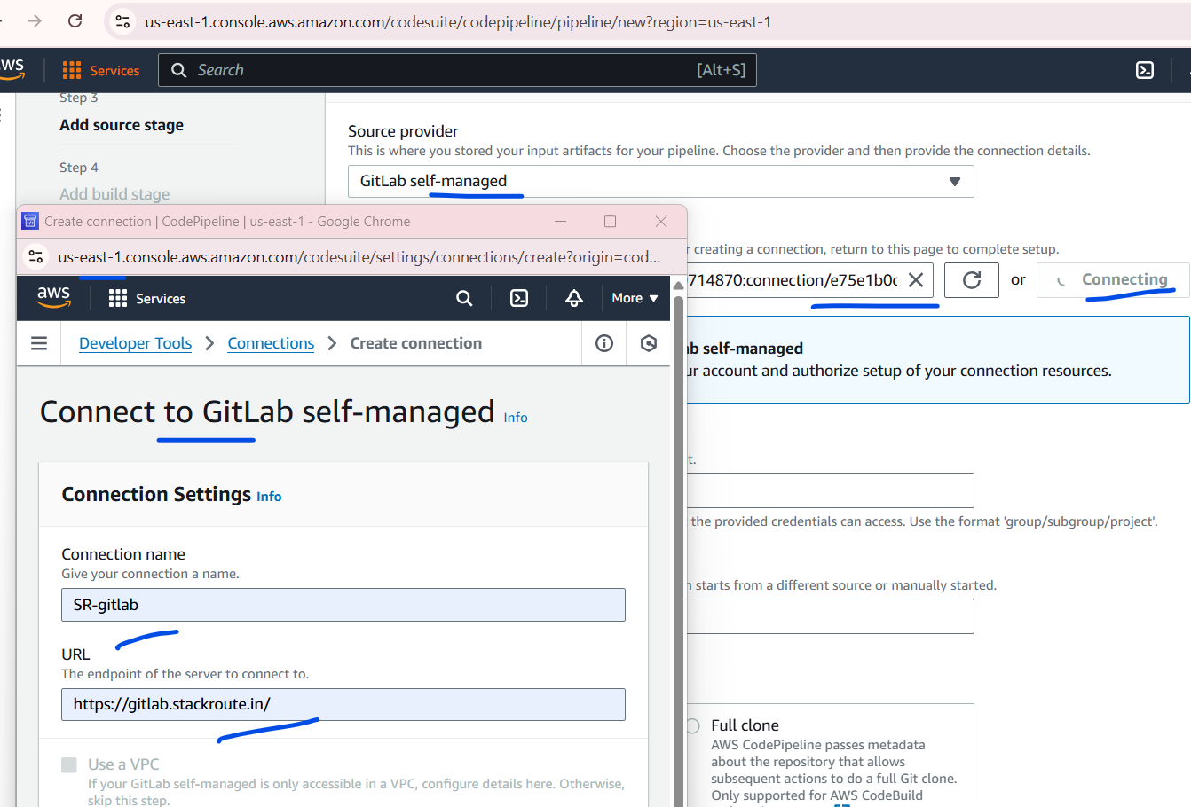
Select the source as Gitlab self-managed.
Click on the “connecting” Button.
Provide the URL of the ‘Stackroute.in” as its an self managed gitlab.

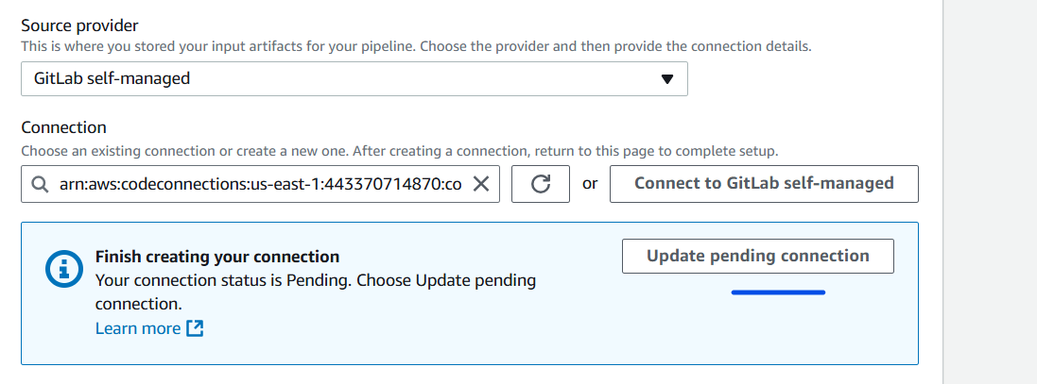
Then click on the “Update pending connection”

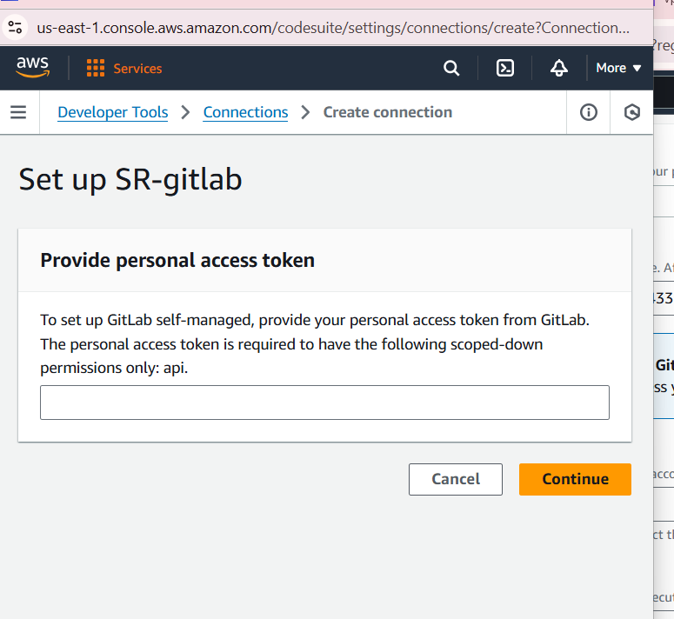

The above screen will pop up. Create an personal access token and paste here.

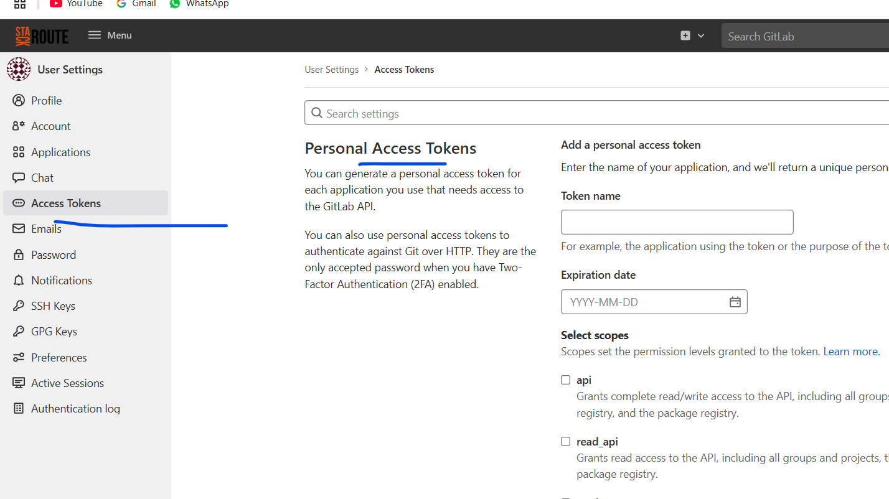
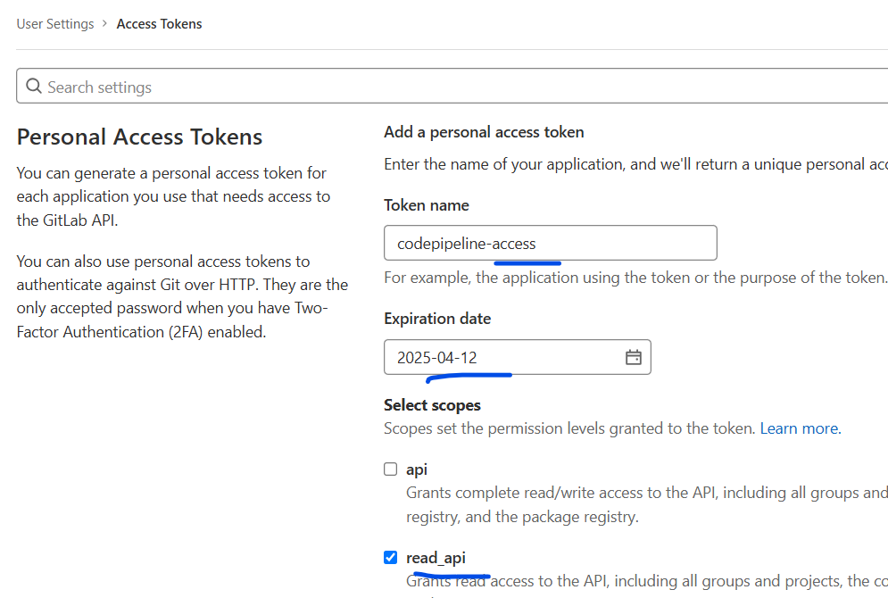
Once created, copy the key and paste on the codepipeline connection popup.

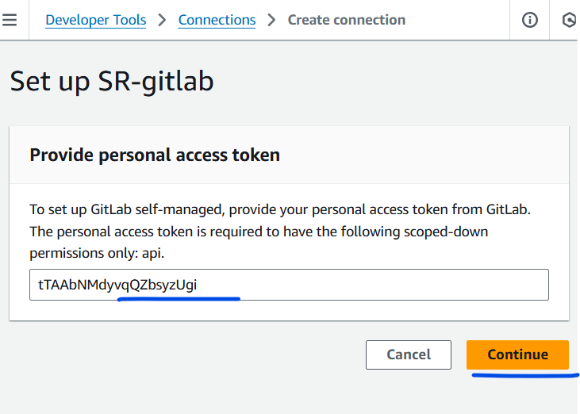
Click Continue
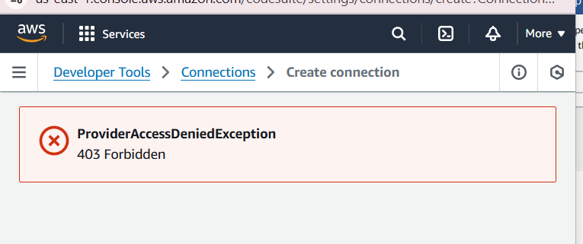
Even the personal token has full access.
Getting “Forbidden access”
Why This Happens
AWS CodePipeline supports:
- GitHub (cloud-hosted) ✔️
- Bitbucket (via HTTPS) ✔️
- CodeCommit ✔️
- ❌ Self-managed GitLab isn't natively supported, so it must be accessed through:
  - An Amazon S3 source trigger
  - A custom webhook / source provider
  - AWS CodeBuild pulling directly from GitLab

Moving to Github.

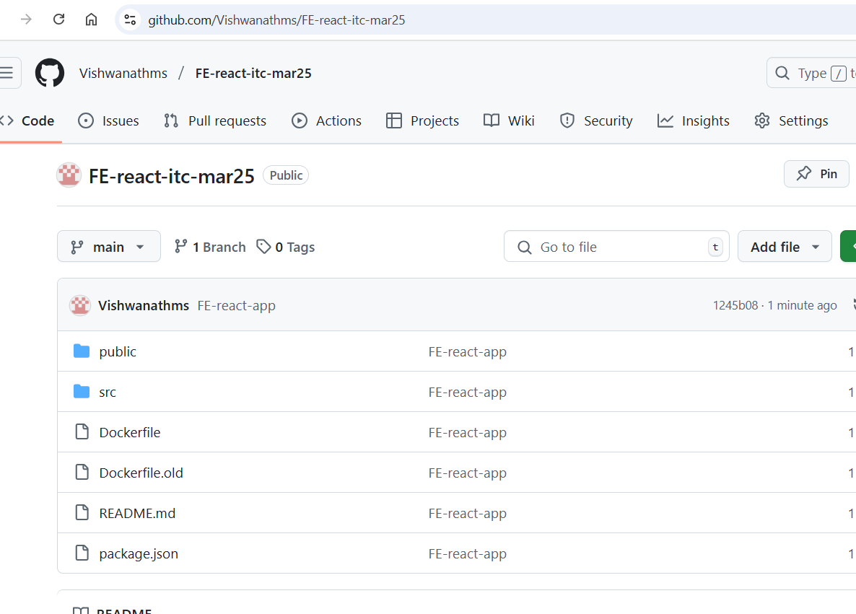
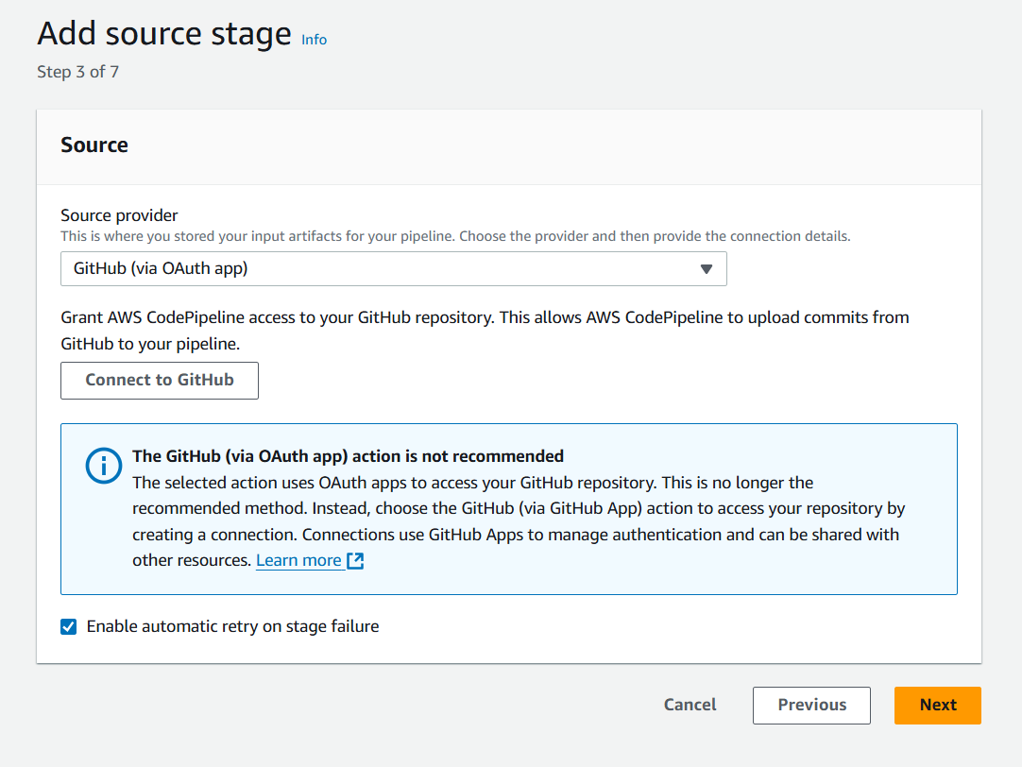
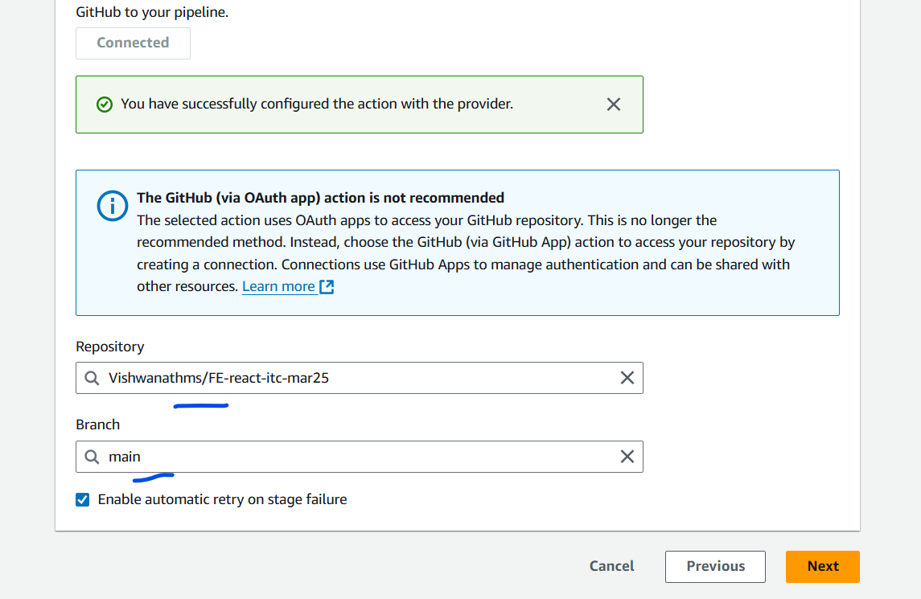

Next
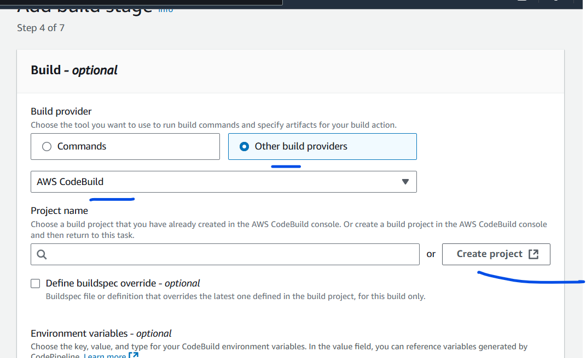
We need to create an project for the code build
The Code build has to do the below tasks
Create docker image and upload to the ECR.

Make sure the codebuild has access to ECR
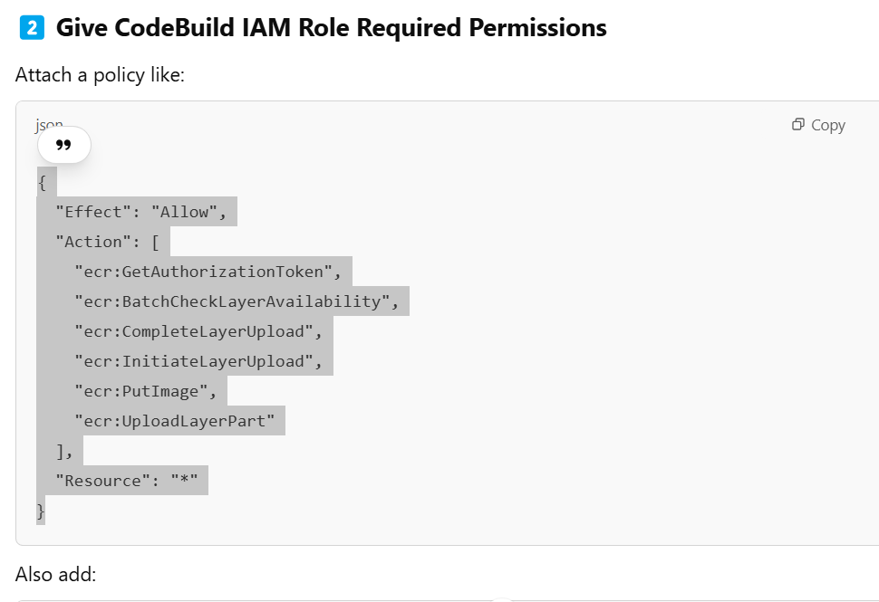
{
"Effect": "Allow",
"Action": [
"ecr:GetAuthorizationToken",
"ecr:BatchCheckLayerAvailability",
"ecr:CompleteLayerUpload",
"ecr:InitiateLayerUpload",
"ecr:PutImage",
"ecr:UploadLayerPart"
],
"Resource": "*"
}
{
"Effect": "Allow",
"Action": "logs:*",
"Resource": "*"
}

Buildspec.yml file
Variables:
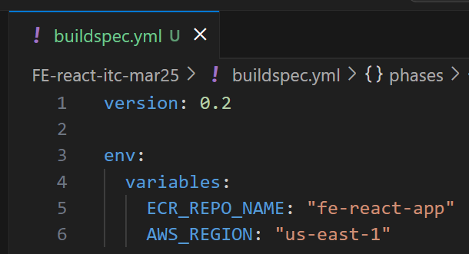
Pre-build – Login details to the ECR
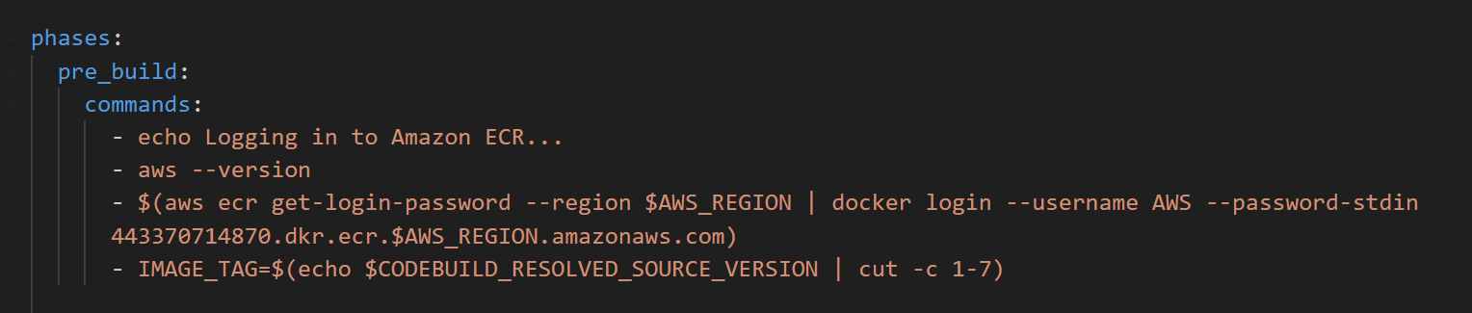

Build
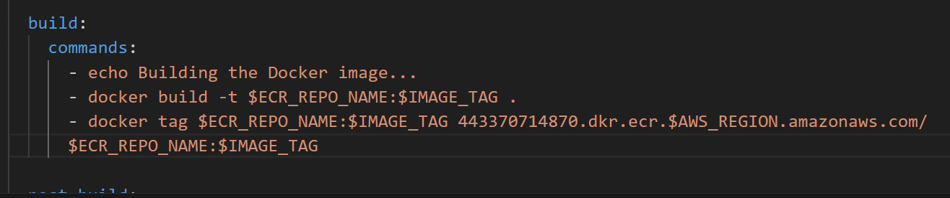

Then push

Step4: Create the build for the Frontend
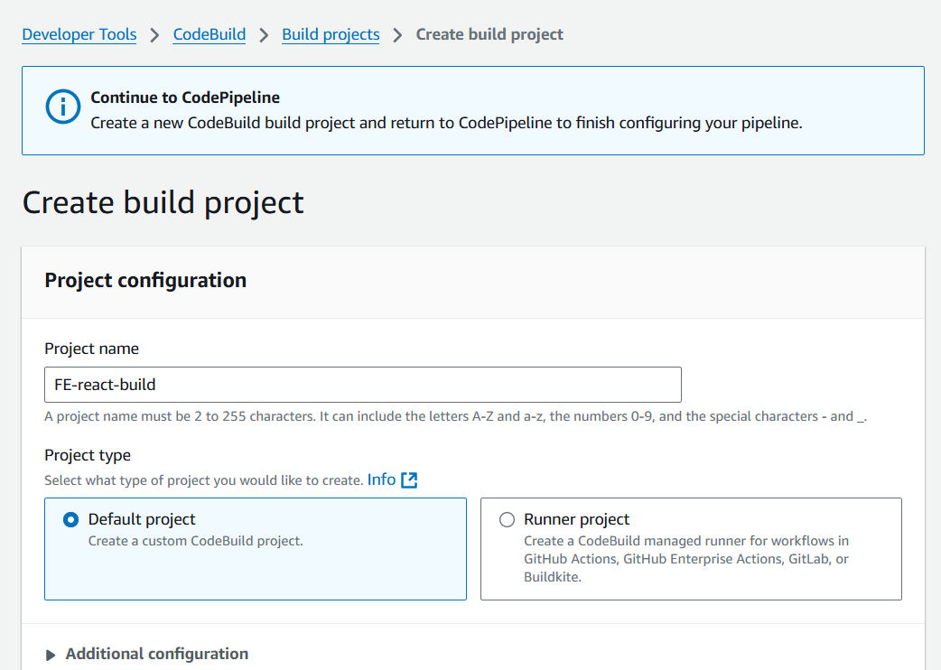

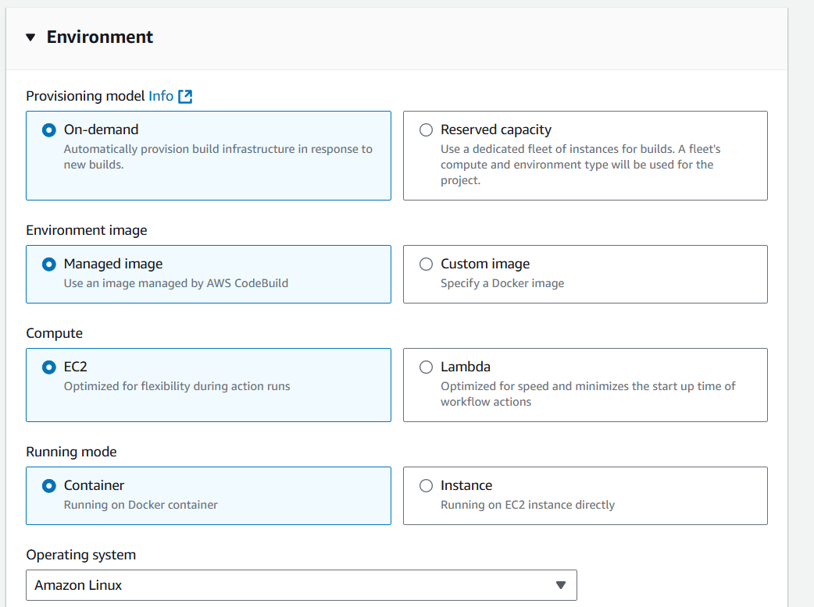
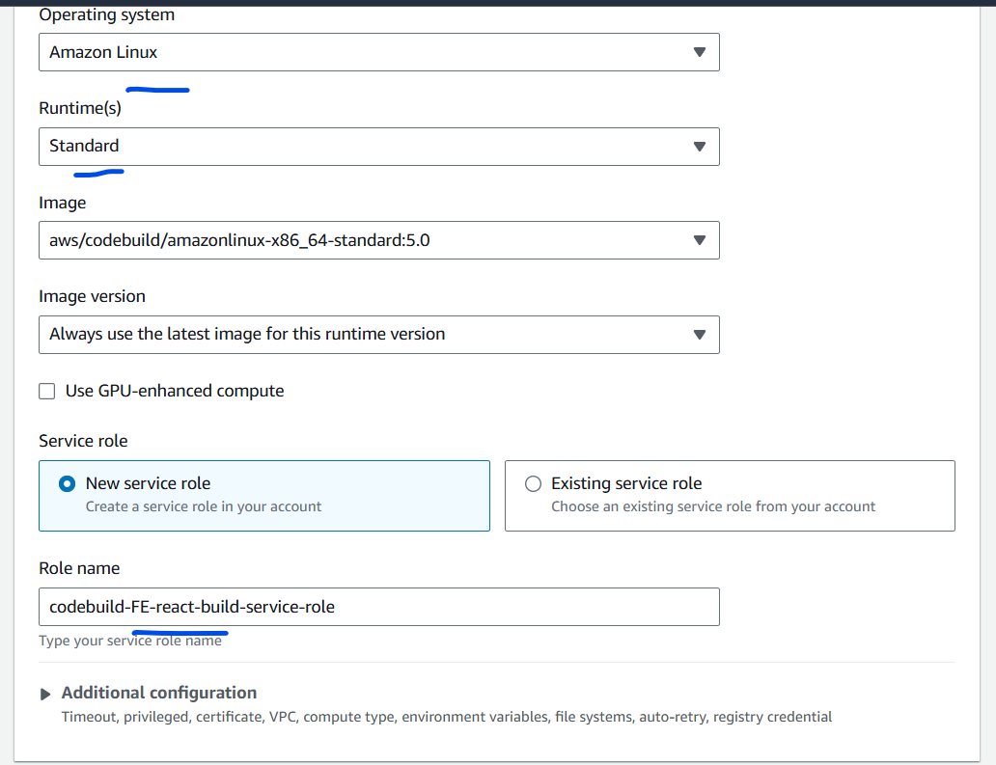
Click on the advanced section
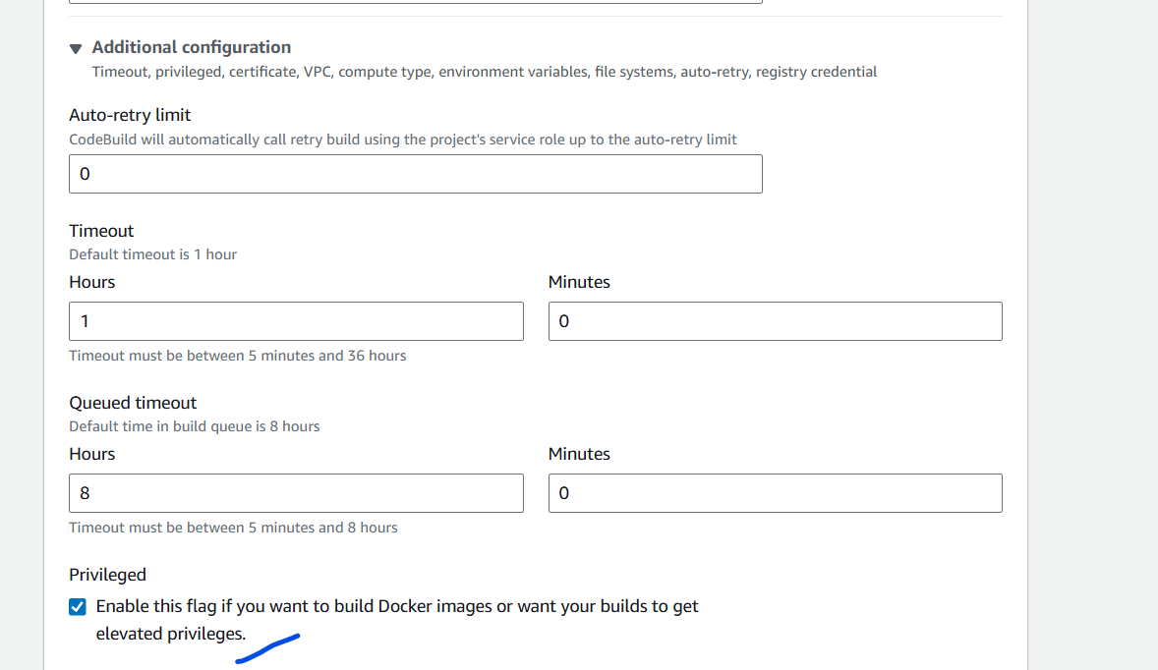

Remember to add the policy that was mentioned above to the “Codebuild Role”
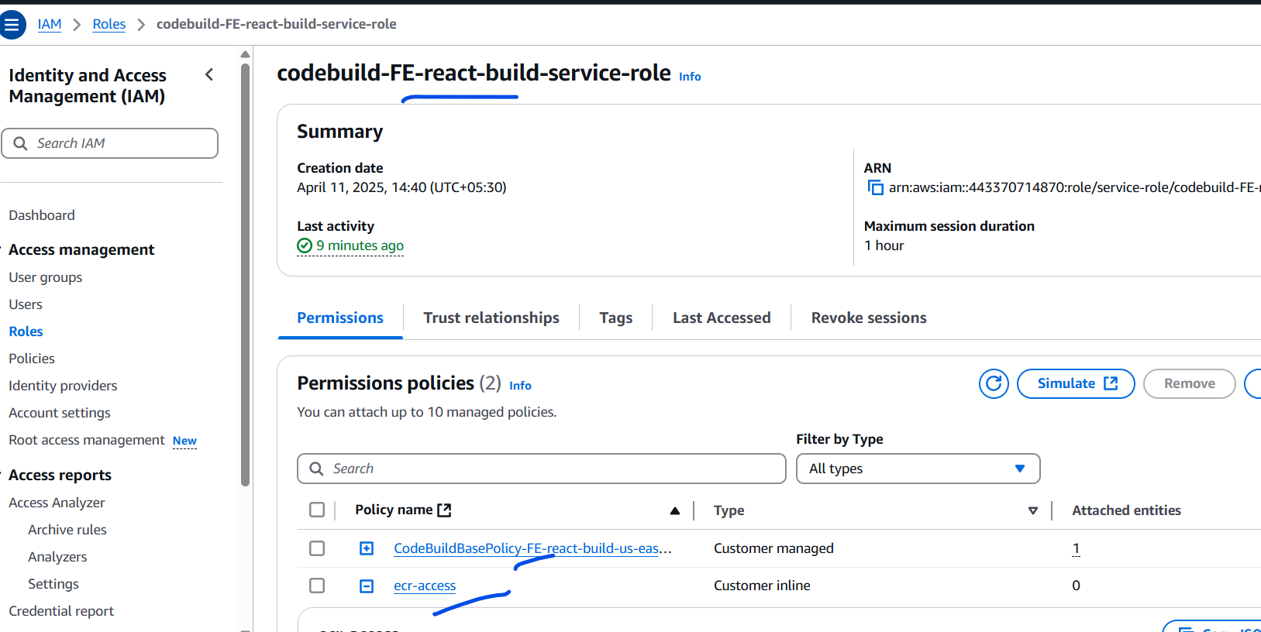
I have attached that policy for the code build
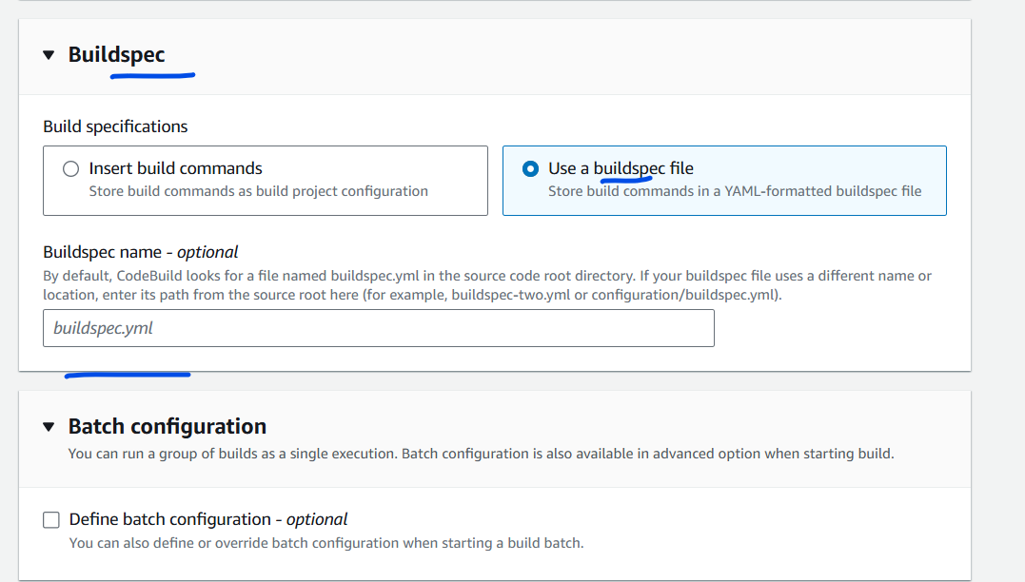
Leave the Buildspec name blank for it to pick the default name.
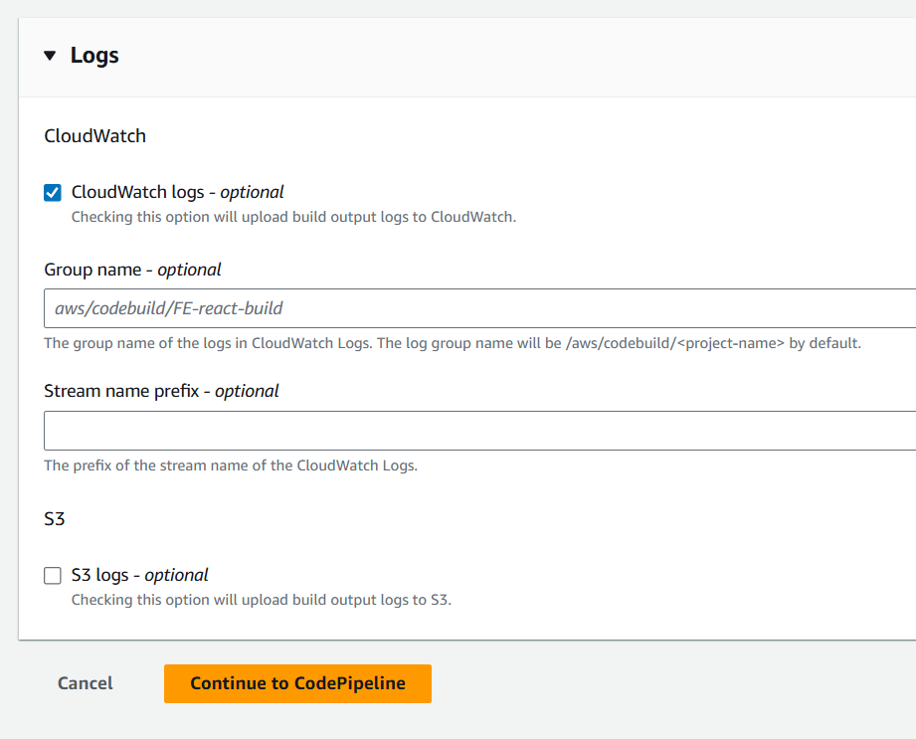
Click on “continue to Codepipeline”
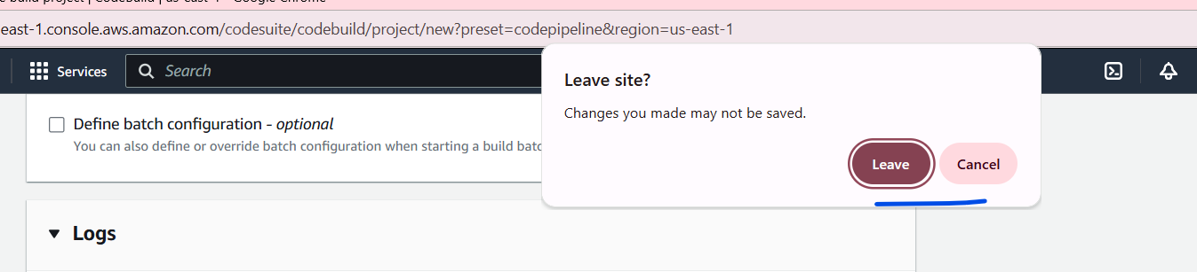

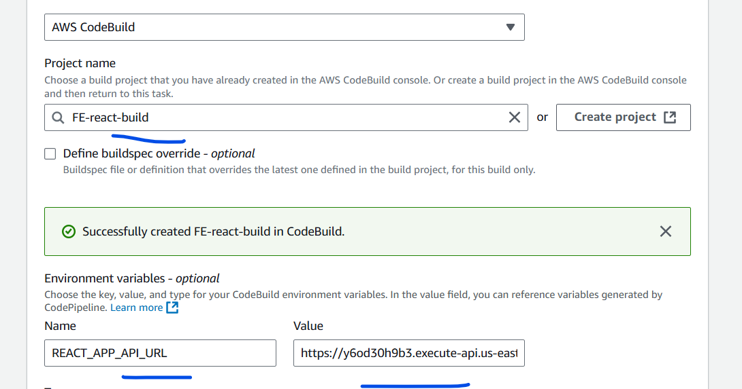

The new build should be visible.
Add the Environment variables for the API URL , that needs to be passed during the docker image build .

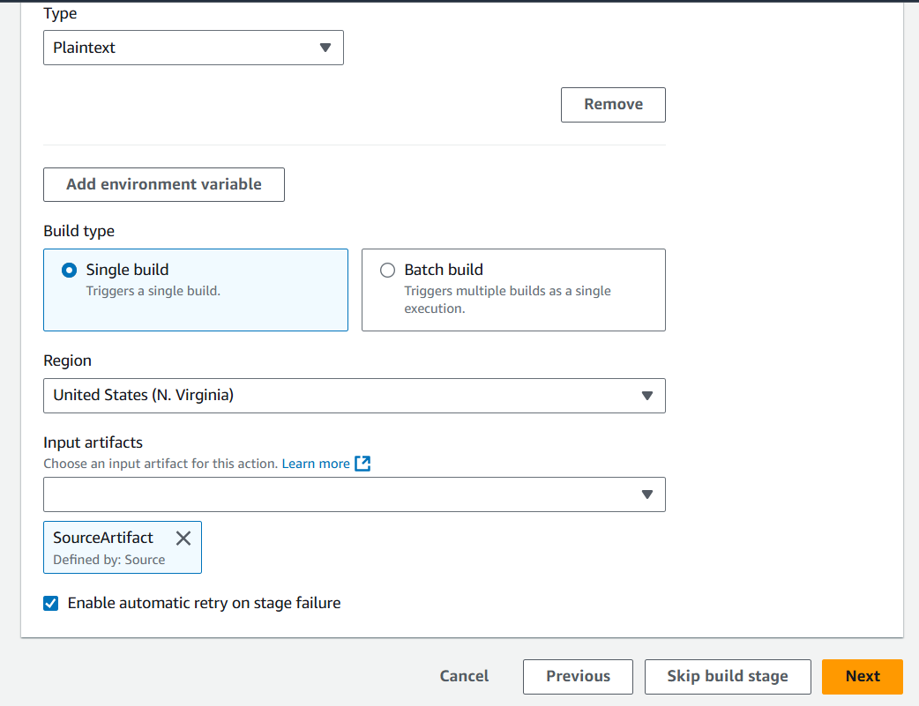
Click on next.

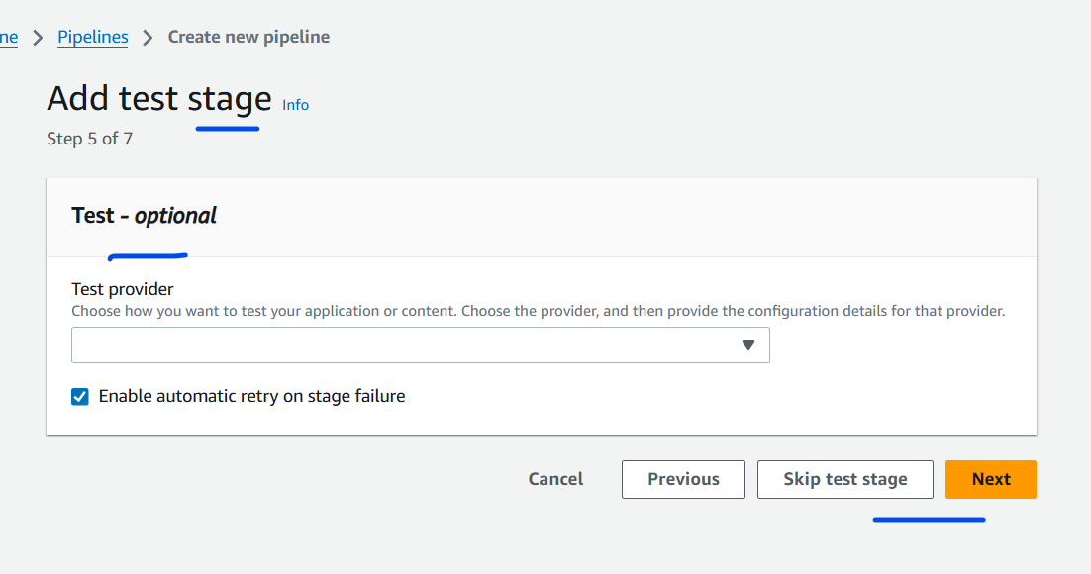
Click Next.

And then create the pipeline.

Note:

